Project 2 Report
CS 316
Authors: Matthew Melton and JT Reagor

Purpose: The purpose of this document is to illustrate the places in our html file where we added css styling, the implementation of that in our css file, as well as an example of the actual element modified on the page.

Background Image:
CSS:
body {
background-image: url("./photos/backgroundImage.jpg");
background-size: 100%;
padding: 5px;
background-position: center;
background-repeat: repeat;
}

HTML: (implements directly in the body of the page)

Screenshot:
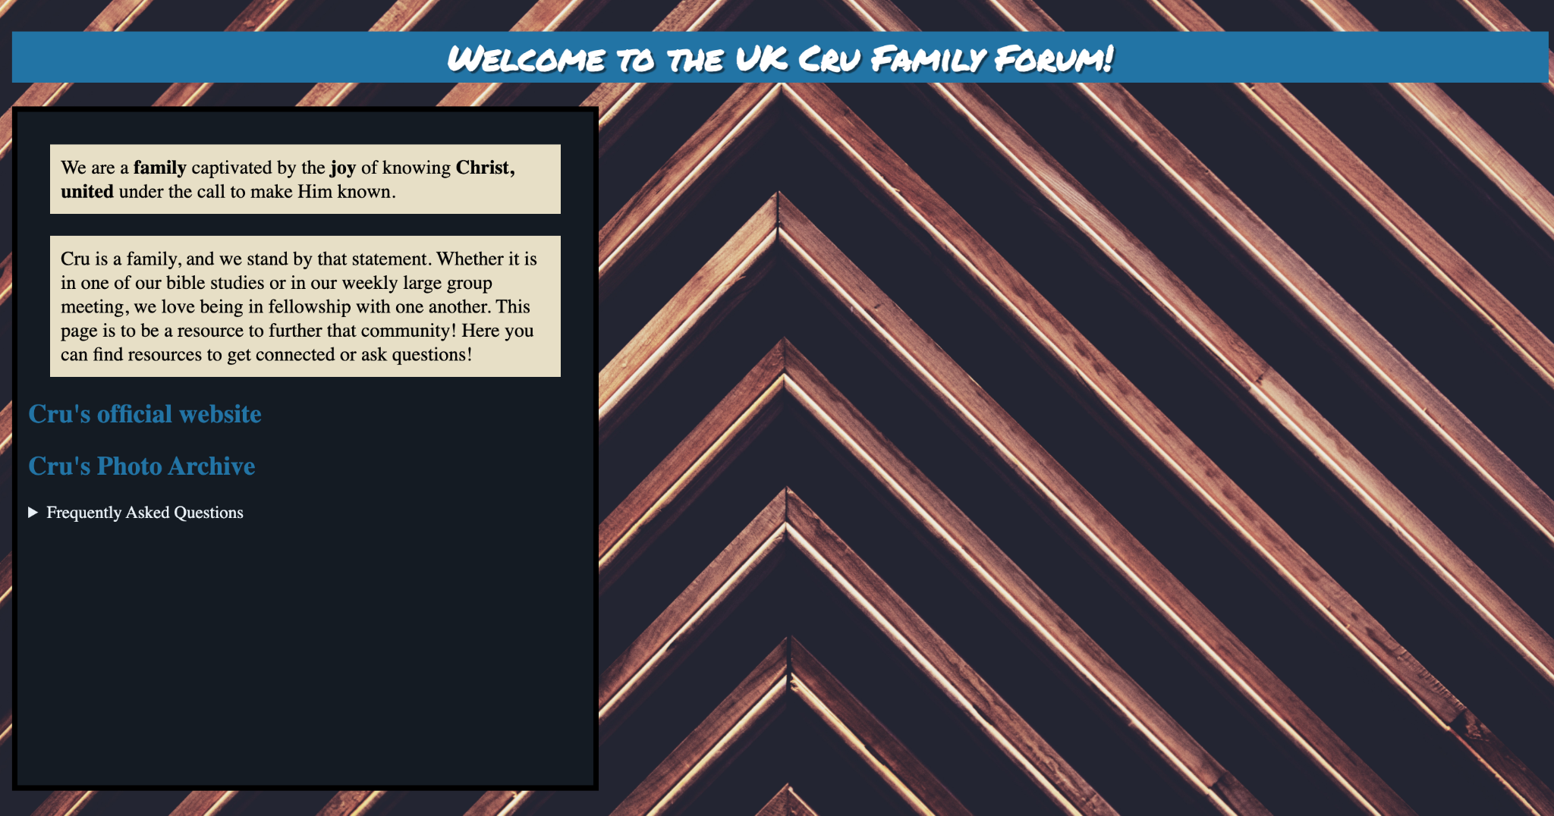

Class selectors:
CSS:
div.mainBody {
border: solid 5px black;
padding: 10px;
width: 510px;
min-height: 600px;
background-color: #131B23;
}
Html implementation:
<div class="mainBody">
<p>We are a <b>family</b> … </div>

Screenshot: (The black box is the “mainBody” div)
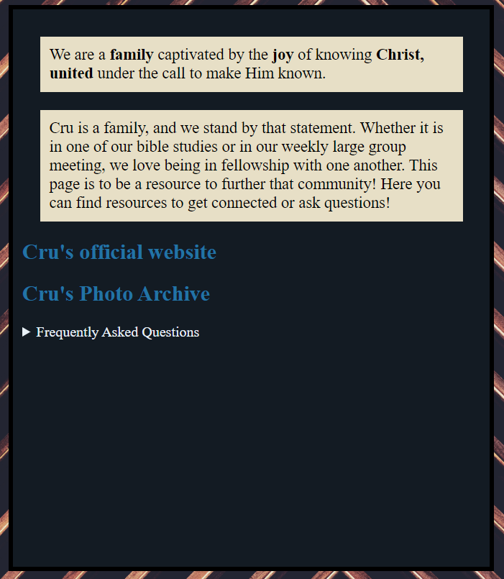

Id selectors:

CSS:

#header{
background-color: #2274A5;
font-family: Marker;
text-align: center;
text-shadow: 2px 2px 1px rgba(0,0,0,0.5);
color: white;
}

HTML:

<h1 id="header">Welcome to the UK Cru Family Forum!</h1>

Screenshot:

Pseudo element selectors for links and hover:

CSS: we added the following blocks of code to our css file for links and hover.
a:link {
text-decoration: none;
color: #2274A5;
}
a:hover {
text-decoration: underline;
font-weight: bold;
}

HTML:
<h2 id="l1"><a href="https://www.cru.org/">Cru's official website</a></h2>
<h2 id="l2"><a href="https://cluster.co/c/nJ2z6pp0WMk/">Cru's Photo Archive</a></h2>

Screenshot:
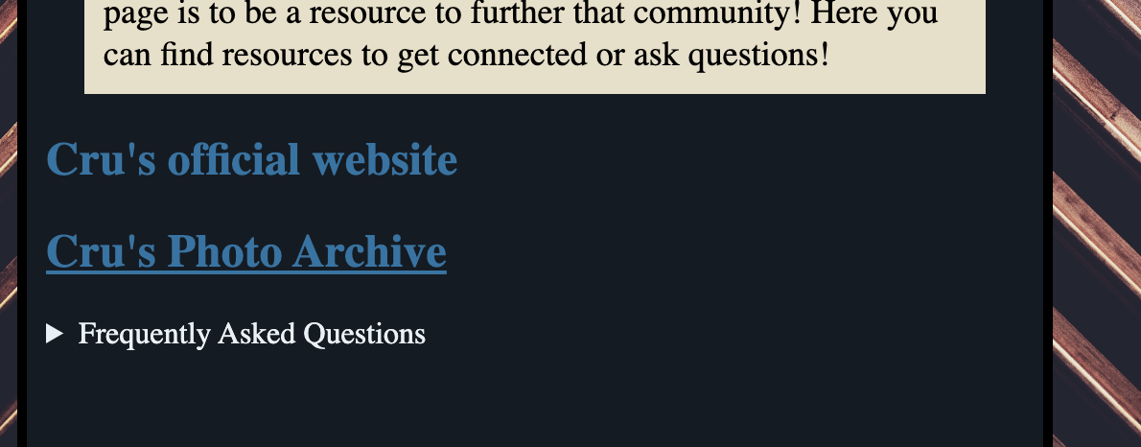
Top link is not being hovered, bottom link is being hovered

Use of the Box Model:

CSS:
div.mainBody {
border: solid 5px black;
padding: 10px;
width: 510px;
min-height: 600px;
background-color: #131B23;
}

p{
color: black;
background-color: #E7DFC6;
margin: 20px;
padding: 10px;
font-size: 18px;
}

HTML:

<div class="mainBody">
<p>...</p>
<p>...</p>
<h2><a href="https://www.cru.org/">Cru's official website</a></h2>
<h2><a href="https://cluster.co/c/nJ2z6pp0WMk/">Cru's Photo Archive</a></h2>
<details>
<summary>Frequently Asked Questions</summary>
<ul>
<li>...</li>
<li>...</li>
<li>...</li>
</ul>
<img src="./Photos/Cru_Question.jpeg" alt="Question" ></img>
</details>
</div>

Screenshot:

Element Selectors:
CSS:

img {
max-width: 100%;
}

HTML:

<img src="./Photos/Cru_Question.jpeg" alt="Question" ></img>

Screenshot:



CSS text styling:

Css (added a custom font):
@font-face {
font-family: 'Marker';
src: url('./Fonts/PermanentMarker-Regular.ttf');
}

#header{
background-color: #2274A5;
font-family: Marker;
text-align: center;
text-shadow: 2px 2px 1px rgba(0,0,0,0.5);
color: white;
}

HTML:
<h1 id="header">Welcome to the UK Cru Family Forum!</h1>

Screenshot:

